# A SMART CABINET OR DESK DRAWER PROTECTOR USING ESP8266

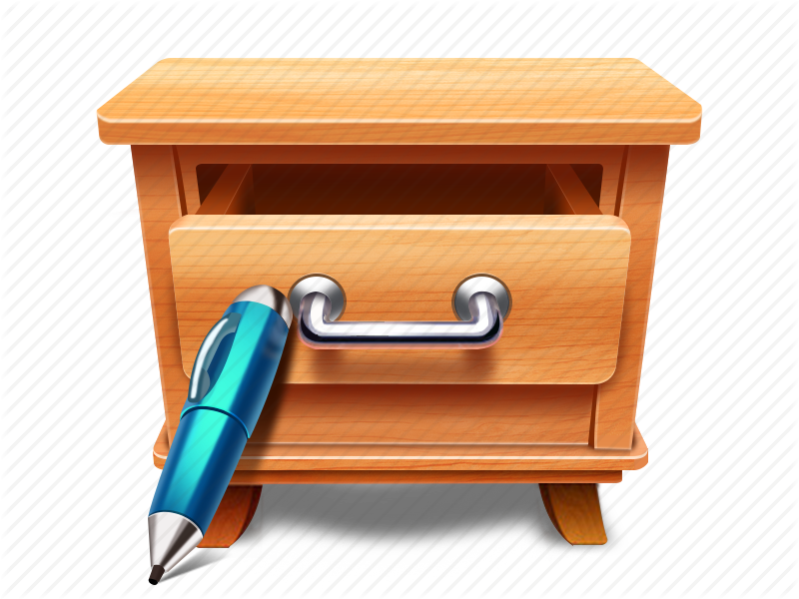

Submitted to: Submitted By:

##### Mr. Subhendru Guha Neogi Shivani Upadhyay Assistant Professor (CSE) (13CS001745)



**Department of Computer Science & Engineering**

SCHOOL OF ENGINEERING

SIR PADAMPAT SINGHANIA UNIVERSITY, UDAIPUR

**APRIL 2017**